TASK | Protective coating sprayed onto brake back plates to prevent corrosion in cold storage environments.
LOCATION OF USE | Workshop |  | Assessment  No |  | 033
PRODUCT NAME | Cold Galvanise
DESCRIPTION OF SUBSTANCE | Grey liquid paint in aerosol
MANUFACTURER | CRC Industries UK Ltd.
MANUFACTURERS CONTACT | Wylds Road  Castlefield Industrial Estate  Bridgwater Somerset  TA6 4DD  +44 1278 727200
ASSESSOR | Martin Monaghan CMIOSH |  | Date |  | 04 12 25
TITLE | Health and Safety Consultant |  | Review by |  | 04 12 27
Personnel Performing Task  (Please list below)  Workshop Operatives |  | Time Spent  (Minutes/day)  As and when required, amounting to a few minutes per day | Training Given 
 |  |  | Yes

MSDS Revision Date | Hazard Statement
25/03/2022 | H222 - Extremely flammable aerosol.  H229 - Pressurized container: May burst if heated  H336 - May cause drowsiness or dizziness.  H319 - Causes serious eye irritation  H315 - Causes skin irritation.

Assessment to be conducted in Association with Hazard Data Sheets, a full current copy of which must be attached to this assessment.

Please denote the hazardous properties of the substances used in the task with a 

NEW INTERNATIONAL GLOBALLY HARMONISED HAZARD SYMBOLS
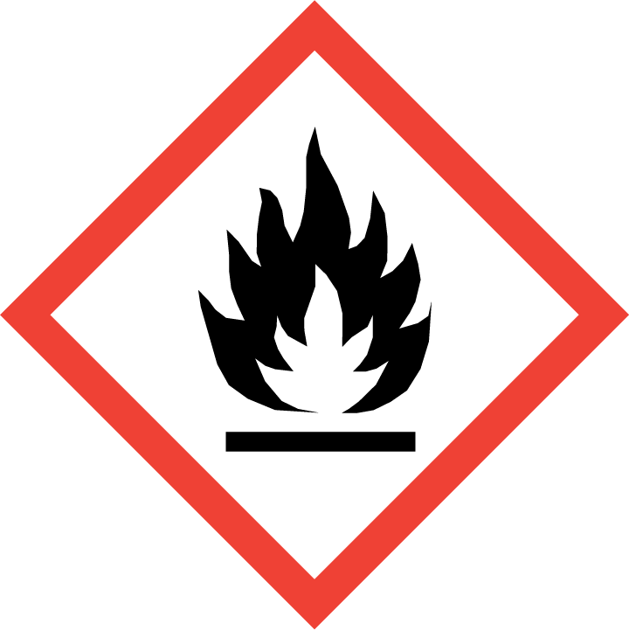 | 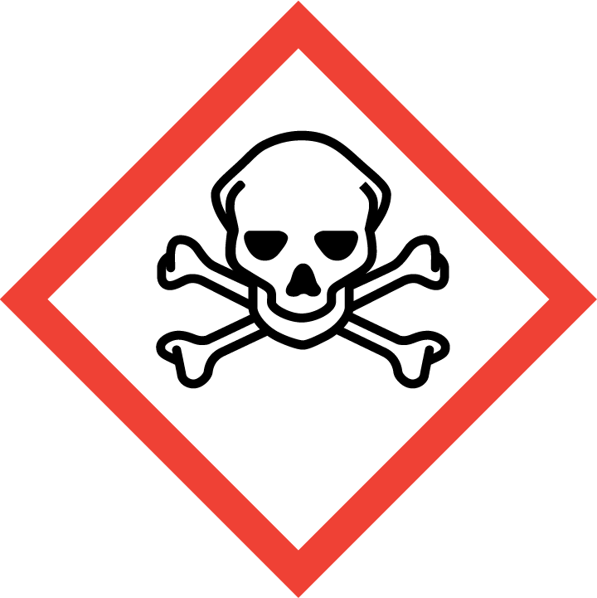 | 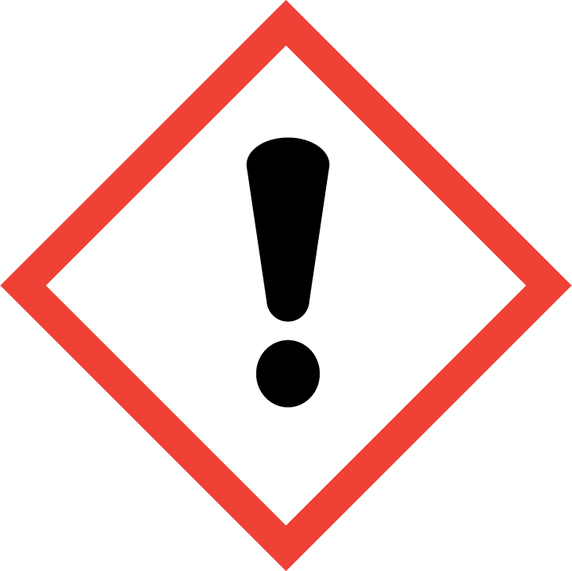 | 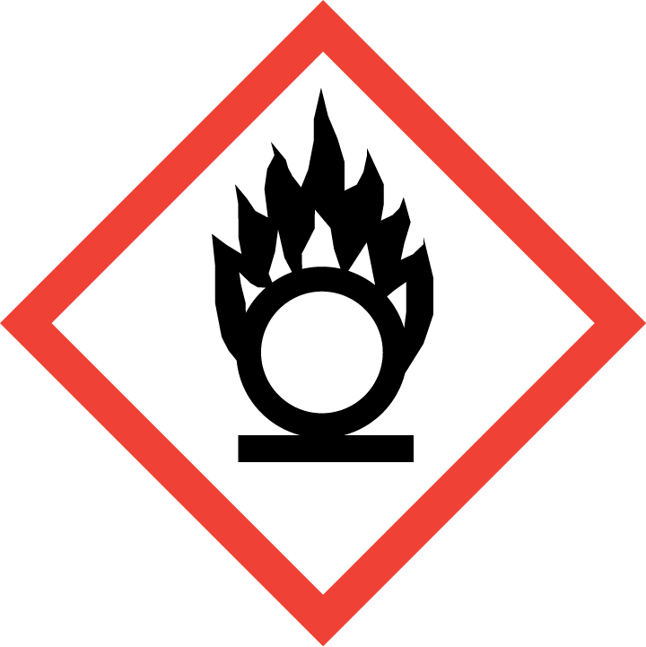 | 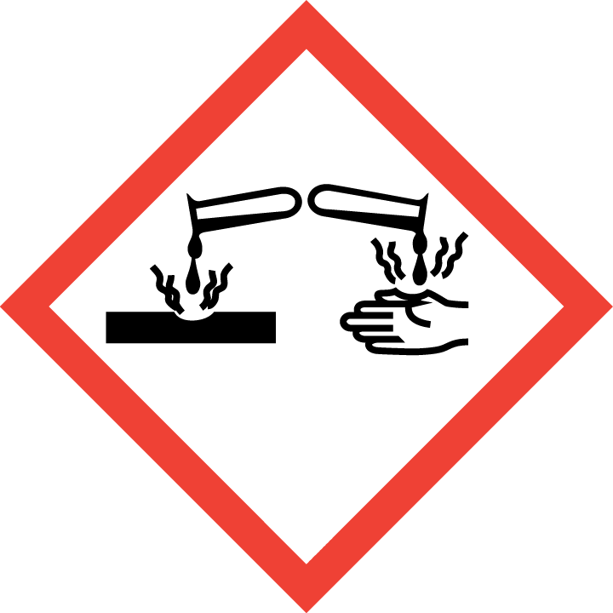 | 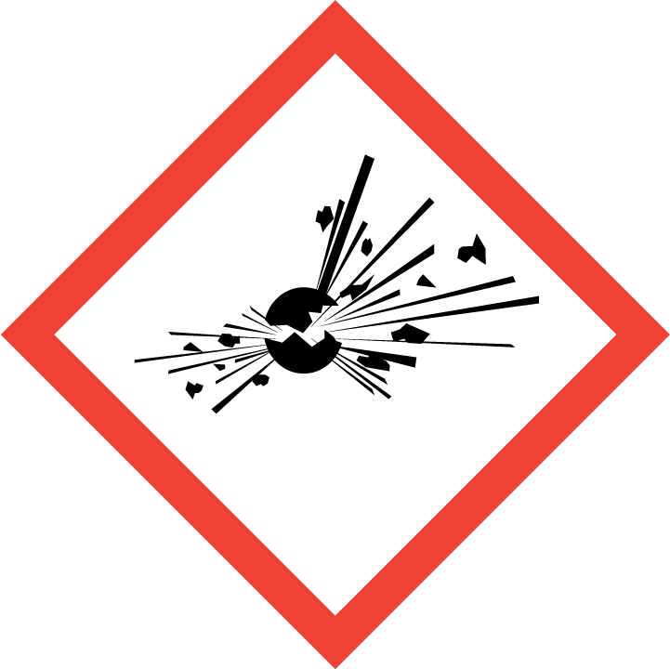 | 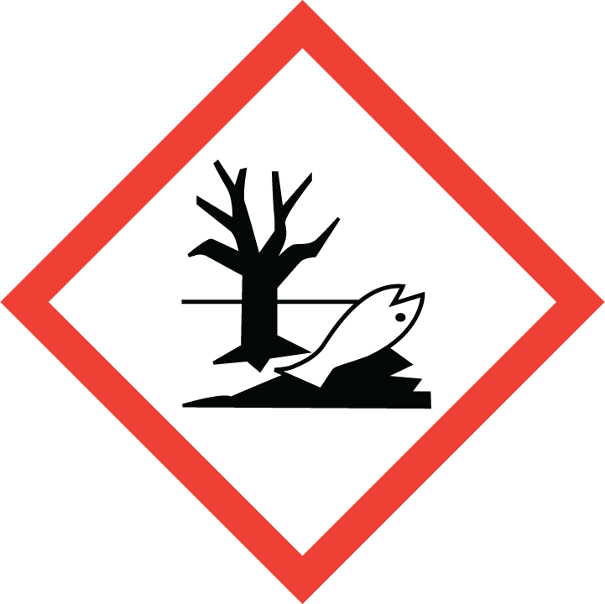 | 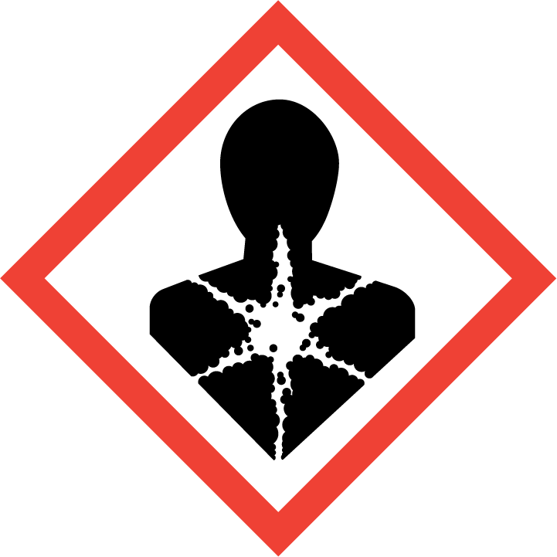
Flammable | Toxic | Danger | Oxidising | Corrosive | Explosive | Harmful to the environment | Health Hazards i.e. respiratory sensitisation or carcinogenicity
 |  |  |  |  |  | 

SMOKING, EATING AND DRINKING ARE PROHIBITED IN THE WORK AREAS.
Information, Instruction and Training must be provided to all users. Young Persons, New or Expectant Mothers and other vulnerable groups must not use or be exposed to this product.

WORKPLACE EXPOSURE LIMITS (WEL’s)
IMPORTANT!
Refer to Workplace Exposure Levels information provided in the Manufacturers Safety Data and revise control measures if exposure levels likely to be reached.

ROUTE OF EXPOSURE
Skin |  | Eyes |  | Inhalation | 
Ingestion |  | Cuts/abrasions |  | Systemic | 

PERSONS AT RISK
User of product |  | Co workers |  | Members of the public

ROUTE OF EXPOSURE |   FIRST AID MEASURES
Eyes | Immediately flush eyes with plenty of water for at least 15 minutes. Remove contact lenses, if present and easy to do. Continue rinsing. Get medical attention if irritation develops and persists.
Skin | Remove contaminated clothing. Wash with plenty of soap and water. If skin irritation occurs: Get medical advice/attention. Wash contaminated clothing before reuse.
Inhalation | Remove victim to fresh air and keep at rest in a position comfortable for breathing. Call a poison centre or doctor/physician if you feel unwell.
Ingestion | In the unlikely event of swallowing contact a physician or poison control centre. Rinse mouth.
In all cases of doubt, or if symptoms persist seek medical attention. Never give anything by mouth to an unconscious person. If unconscious, place in recovery position and seek medical advice.

PERSONAL PROTECTIVE EQUIPMENT
 |  | 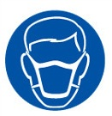 | 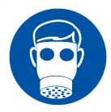 |  | 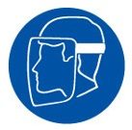
YES | YES | YES/NO | YES | YES | YES/NO
Safety glasses or goggles to EN166 | Suitable long sleeved coveralls. |  |  | PVC or rubber nitrile gloves. EN374

HANDLING | STORAGE | TRANSPORT | DISPOSAL
Pressurised container: Do not pierce or burn, even after use. Do not use if spray button is missing or defective. Do not spray on a naked flame or any other incandescent material. Do not smoke while using or until sprayed surface is thoroughly dry. Do not cut, weld, solder, drill, grind, or expose containers to heat, flame, sparks, or other sources of ignition. All equipment used when handling the product must be grounded. Do not re-use empty containers. Avoid breathing mist/vapours. Avoid contact with eyes, skin, and clothing. Avoid prolonged exposure. Use only in well-ventilated areas. Wear appropriate personal protective equipment. Avoid release to the environment. Observe good industrial hygiene practices | Pressurized container. Protect from sunlight and do not expose to temperatures exceeding 50°C. Do not puncture, incinerate or crush. Do not handle or store near an open flame, heat or other sources of ignition. This material can accumulate static charge which may cause spark and become an ignition source | Harmful paint | Any waste material is classed as hazardous waste, it should only be disposed of through licenced waste handlers and  treatment sites. Do not allow unauthorised disposal to the environment. Avoid sources of ignition when handling waste. If operators are exposed to vapours during the disposal process then suitable respiratory protection should be worn. All other personal protective equipment should be worn.  When handling waste, consideration should be made to the safety precautions applying to handling of the product.

REQUIRED CONTROL MEASURES
- Users to avoid contact with skin and eyes, and inhalation of vapours/ spray or mist arising from the application of this preparation – Use PPE.
- Respiratory protection if there’s a risk of exposure to high vapour concentrations.
- PVC or rubber gloves.
- Chemical goggles if there is a risk of eye contact.
- Normal work wear.
- Ensure operatives are made aware of and understand the purpose of this assessment and MSDS, plus any health implications of using the product.

FIRE PRECAUTIONS
Suitable: In case of fire, use water spray, foam, dry chemical or CO2.
Not suitable: Do not use water jet.

ACCIDENTAL RELEASE/SPILLAGE PROCEDURES
Evacuate surrounding areas. Keep unnecessary and unprotected personnel from entering. Do not touch or walk through spilt material. Shut off all ignition sources. No flares, smoking or flames in hazard area. Avoid breathing vapour or mist. Provide adequate ventilation. Wear appropriate respirator when ventilation is inadequate. Put on appropriate personal protective equipment.

MONITORING REQUIREMENTS AND HEALTH SURVEILLANCE
Annual Health surveillance is place for workers exposed to this product (Lung function and Urine samples)

